**Digital Twin Analytics - Manufacturing Sector**

GOKULNATH K & E24755

**Overview**

Digital twin analytics in the manufacturing sector involves creating virtual replicas of physical systems to simulate, monitor, and optimize production processes in real-time. It enables predictive maintenance, operational efficiency, and process improvements by analyzing sensor data and identifying patterns. This approach enhances decision-making by providing insights into system behavior and future outcomes. Data analytics plays a critical role by transforming real-time data into actionable insights, driving innovation and reducing downtime.

**Objective**

1. Optimize production processes through real-time data analysis and simulations.
2. Improve predictive maintenance by forecasting equipment failures.
3. Enhance decision-making with virtual models of physical assets.
4. Reduce downtime and operational costs through proactive interventions.
5. Increase operational efficiency by identifying bottlenecks and inefficiencies.
6. Enable continuous monitoring and optimization of manufacturing systems.
7. Support innovation by testing scenarios and process improvements in a virtual environment.

**Assigned Task(s)**

* Digital Twin Analytics - Manufacturing Sector

**Task Details**

* **Task 29 :** Digital twin analytics in the manufacturing sector involves using virtual models of physical assets to analyze real-time data, optimize processes, and improve operational efficiency. It enables predictive maintenance and informed decision-making through continuous system monitoring.
* **Status:** Completed.
* **Details:**

1. **Analyzed Dataset:**Analyzed dataset with columns for time, sensor readings (Sensor1, Sensor2), production inputs and outputs, and a maintenance flag.
2. **DataFrame Conversion:**  
   The dataset is converted into a Pandas DataFrame for easy manipulation and analysis.
3. **Efficiency Calculation:**  
   Production efficiency is calculated as the ratio of Production_Output to Production_Input, added as a new column in the DataFrame.
4. **Sensor1 Visualization:**  
   A line plot of Sensor1 over time is created, highlighting maintenance events with red markers based on the Maintenance_Flag.
5. **Production Efficiency Visualization:**  
   A line plot is generated to visualize production efficiency over time.
6. **Correlation Analysis:**  
   The code calculates the correlation matrix between Sensor1, Sensor2, and Production_Output to analyze relationships between these variables.
7. **Correlation Matrix Visualization:**  
   A heatmap is generated to visualize the correlation matrix, providing insights into the dependencies among sensor data and production output.
8. **Pie Chart of Maintenance Events:**  
   A pie chart is created to visualize the proportion of maintenance events, showing the ratio of periods with and without maintenance.
9. **Sensor Comparison Visualization:**  
   A line chart comparing Sensor1 and Sensor2 values over time is plotted to observe their trends and relationships.
10. **Anomaly Detection:**  
    Anomalies in Sensor1 are detected based on a threshold (95th percentile), and a new column is added to flag these anomalies.
11. **Anomaly Detection Visualization:**  
    A plot of Sensor1 is created with highlighted anomalies, providing visual insight into potential issues that may require attention.

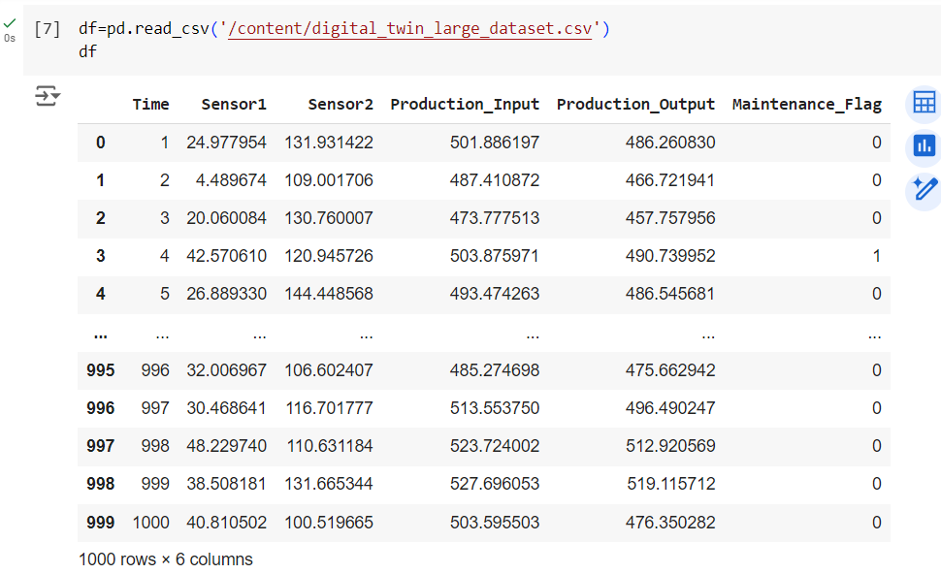

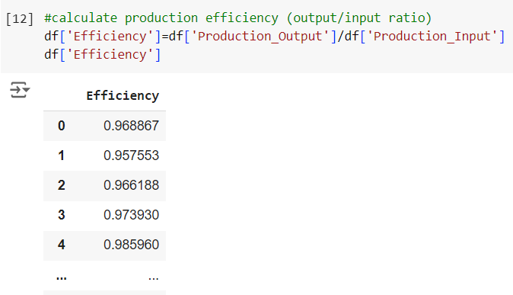

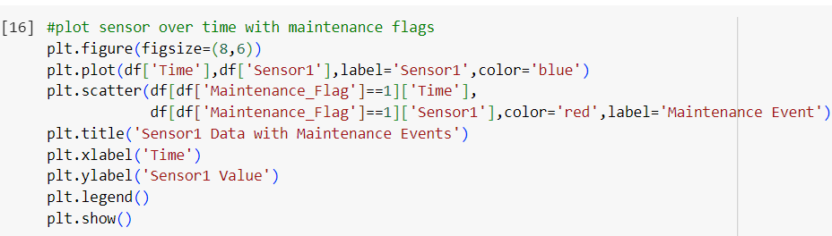

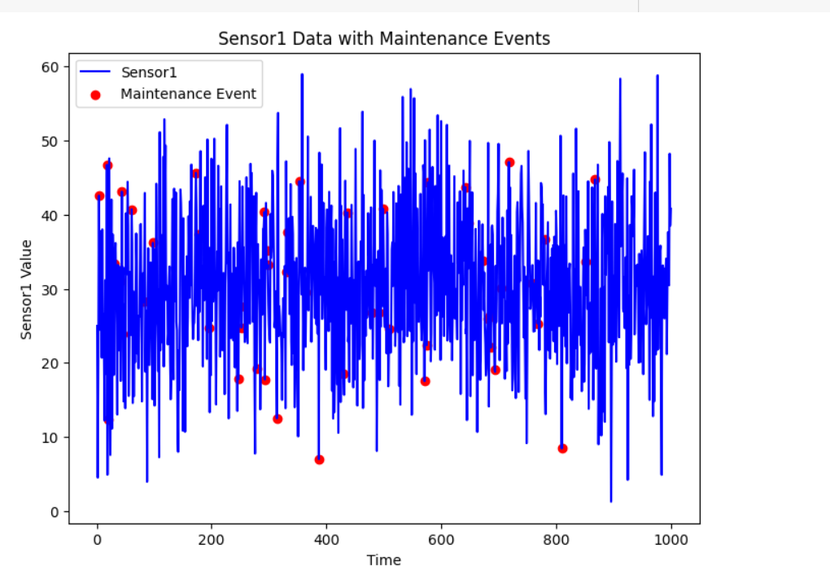

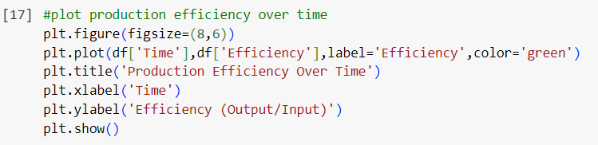

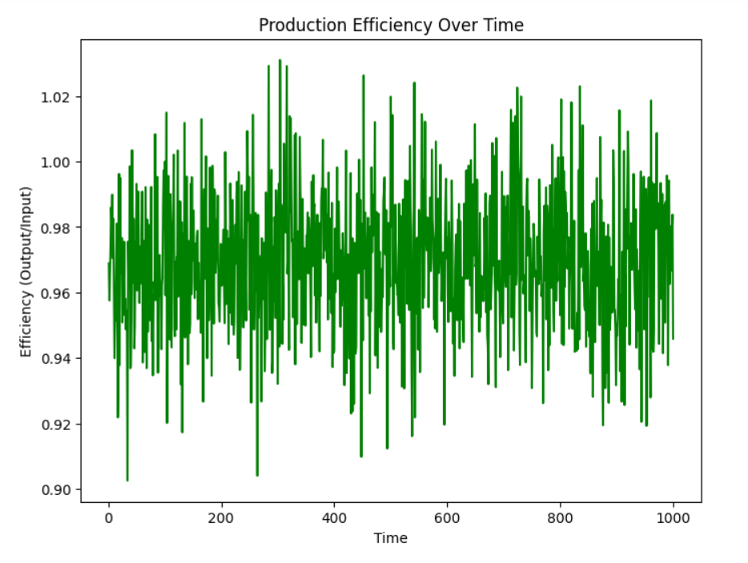

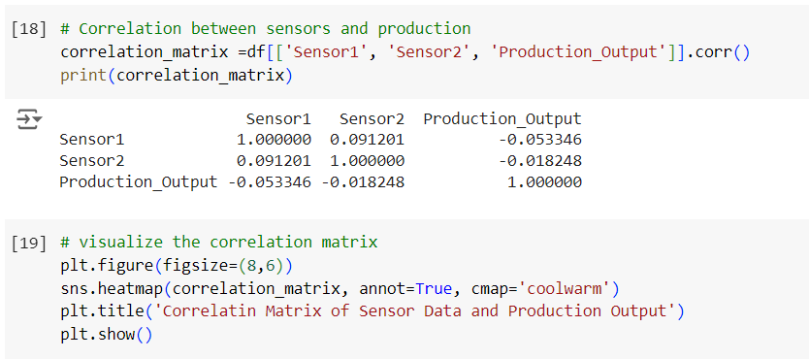

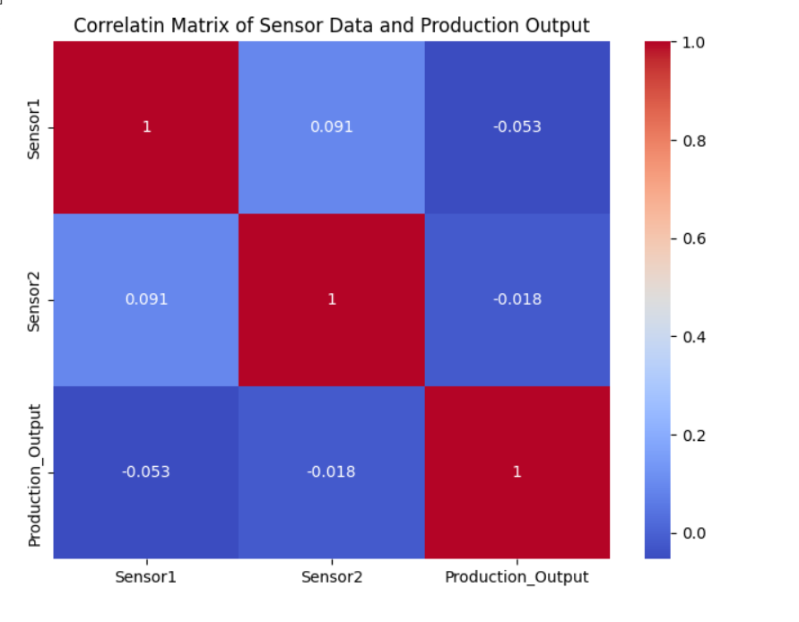

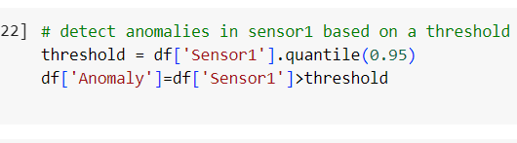

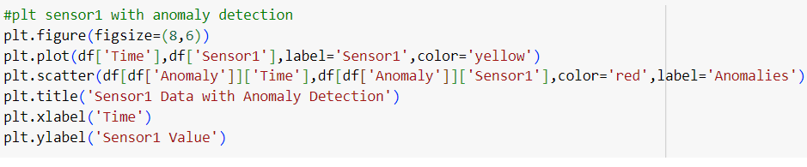

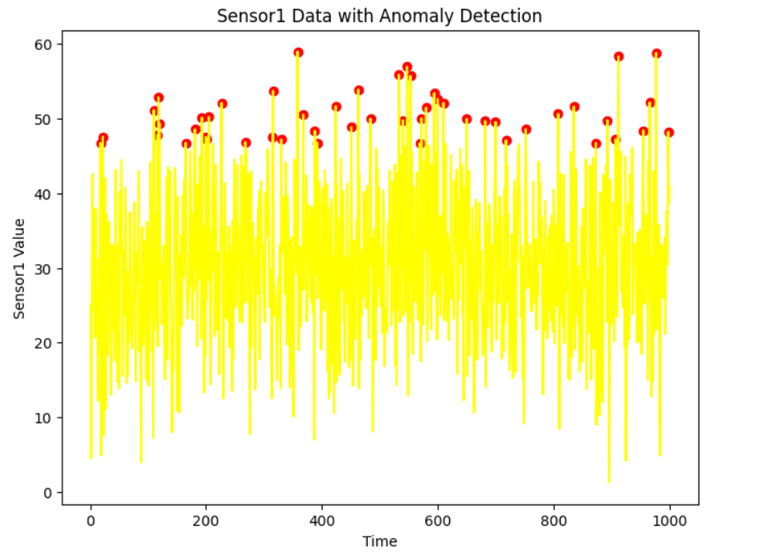

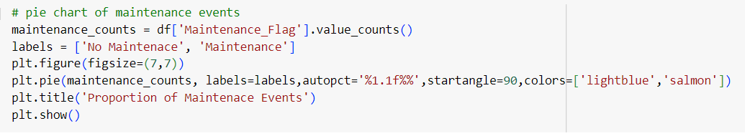

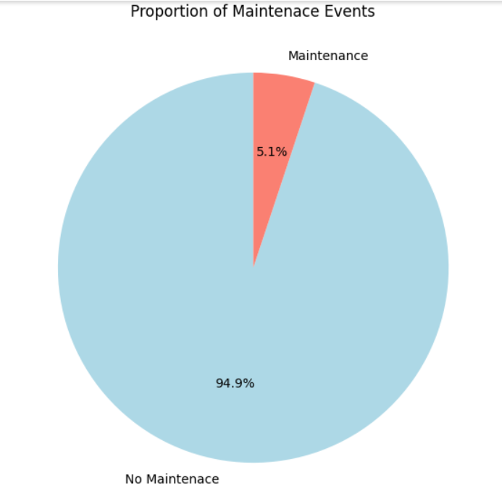

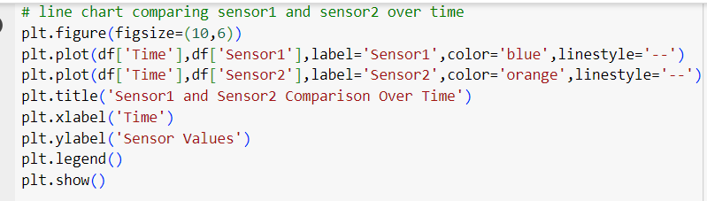

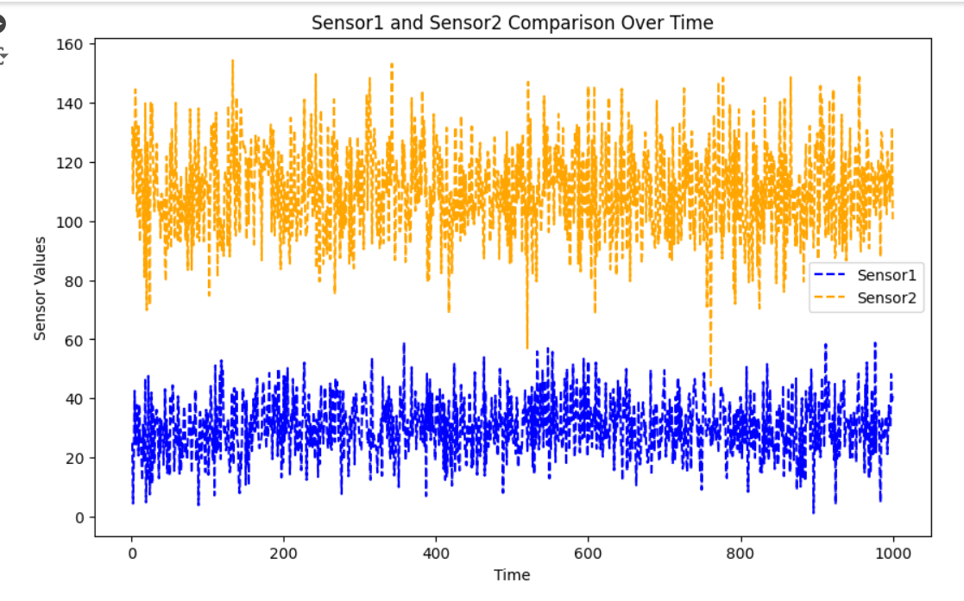

**Progress**

* **Accomplishments:** Developed a comprehensive digital twin analytics framework that enables real-time monitoring, efficiency calculations, anomaly detection, and visualization of sensor data in the manufacturing sector.
* **Metrics:**

1. Production Efficiency: Ratio of Production_Output to Production_Input.
2. Anomaly Detection Threshold: 95th percentile of Sensor1 for anomaly identification.
3. Maintenance Event Count: Total instances of Maintenance_Flag set to 1.
4. Correlation Coefficients: Relationships between Sensor1, Sensor2, and Production_Output.
5. Sensor1 Anomaly Count: Total detected anomalies in Sensor1.
6. Sensor Readings Visualization: Trends of Sensor1 and Sensor2 over time.
7. Efficiency Over Time: Changes in production efficiency across the dataset.

**Challenges and Solutions**

* **Challenges Faced:** Difficulty in handling large volumes of sensor data and ensuring data quality for accurate analysis.
* **Solutions Implemented:** Utilized data preprocessing techniques and automated monitoring systems to streamline data cleaning and enhance analysis efficiency.

**Next Steps**

* **Upcoming Tasks:** Prioritize tasks by leveraging advanced analytics and data visualization tools to enhance decision-making and optimize production processes.
* **Goals:** Set clear goals and utilize data-driven strategies to continuously improve operational efficiency and innovation in manufacturing processes.

**Conclusion**

* **Summary:** Digital twin analytics in the manufacturing sector enhances real-time monitoring and decision-making by integrating sensor data with production processes. By focusing on metrics like production efficiency and anomaly detection, organizations can improve operational reliability and productivity. Emphasizing data quality and advanced analytics strategies will drive future innovations and efficiencies in manufacturing.
* **Acknowledgments:** Thank you all for your attention and engagement, I appreciate your interest in the Digital Twin Analytics in Manufacturing sector.